

**Popup Deployment Procedure**

* **Slow Ship to safe working speed (4-10kts)**
* **Position pop-up near stern**
* **Pass a slip line through the anchor**
* **Gently push float off the stern while maintaining positive control of the anchor**
* **Allow the float to trail aft of the stern**
* **Once the cable and float are streaming out straight from the anchor, lower anchor to the water line and let slip**
* **Mark deployment location and time in UTC**

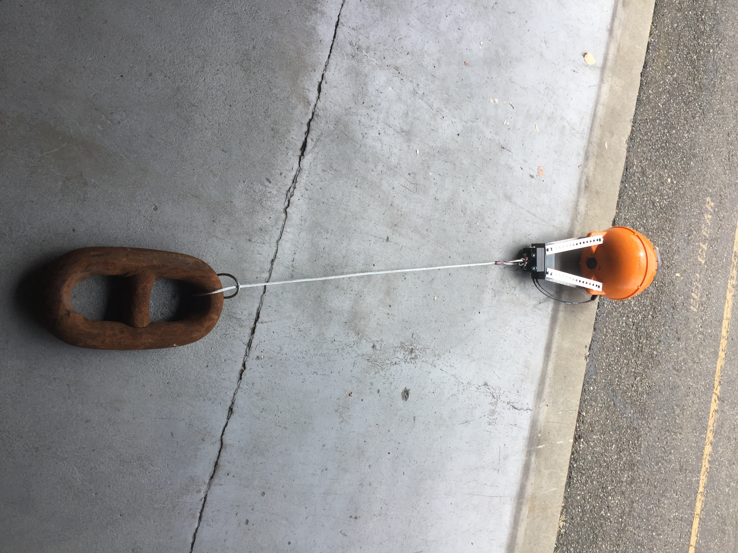

POPUP GEN. 4  
DEPLOYMENT PROCEDURES  
SUMMER / FALL 2020

Point of Contact  
  
LTJG Sarah Donohoe  
sarah.s.donohoe@noaa.gov   
office 206-526-6746  
  
Background

The pop-up floats are one of several new technologies in development by the Innovative Technology for Arctic Exploration (ITAE) program. They are compact instruments housed in low-cost commercial crab floats and optimized for use in the relatively shallow waters of the Arctic continental shelf. The flaots are expendable and capable of providing approximately 18 months of data transmitted via Iridium short-burst-data messages; designed to be sunk with an anchor and a timed burn-wire release at sea during late summer to early fall in ice-free conditions. At a pre-programmed release date the burn wire will release the anchor and the sensors will capture a single water column profile as it rises and gets trapped under the ice. In this phase the pop-up collects oceanographic data on conditions directly under Arctic sea ice during spring and early summer. Once the Arctic sea ice retreats and the float is freed the pop-up begins transmitting stored data and location until battery life is fully drained.

1a

1b

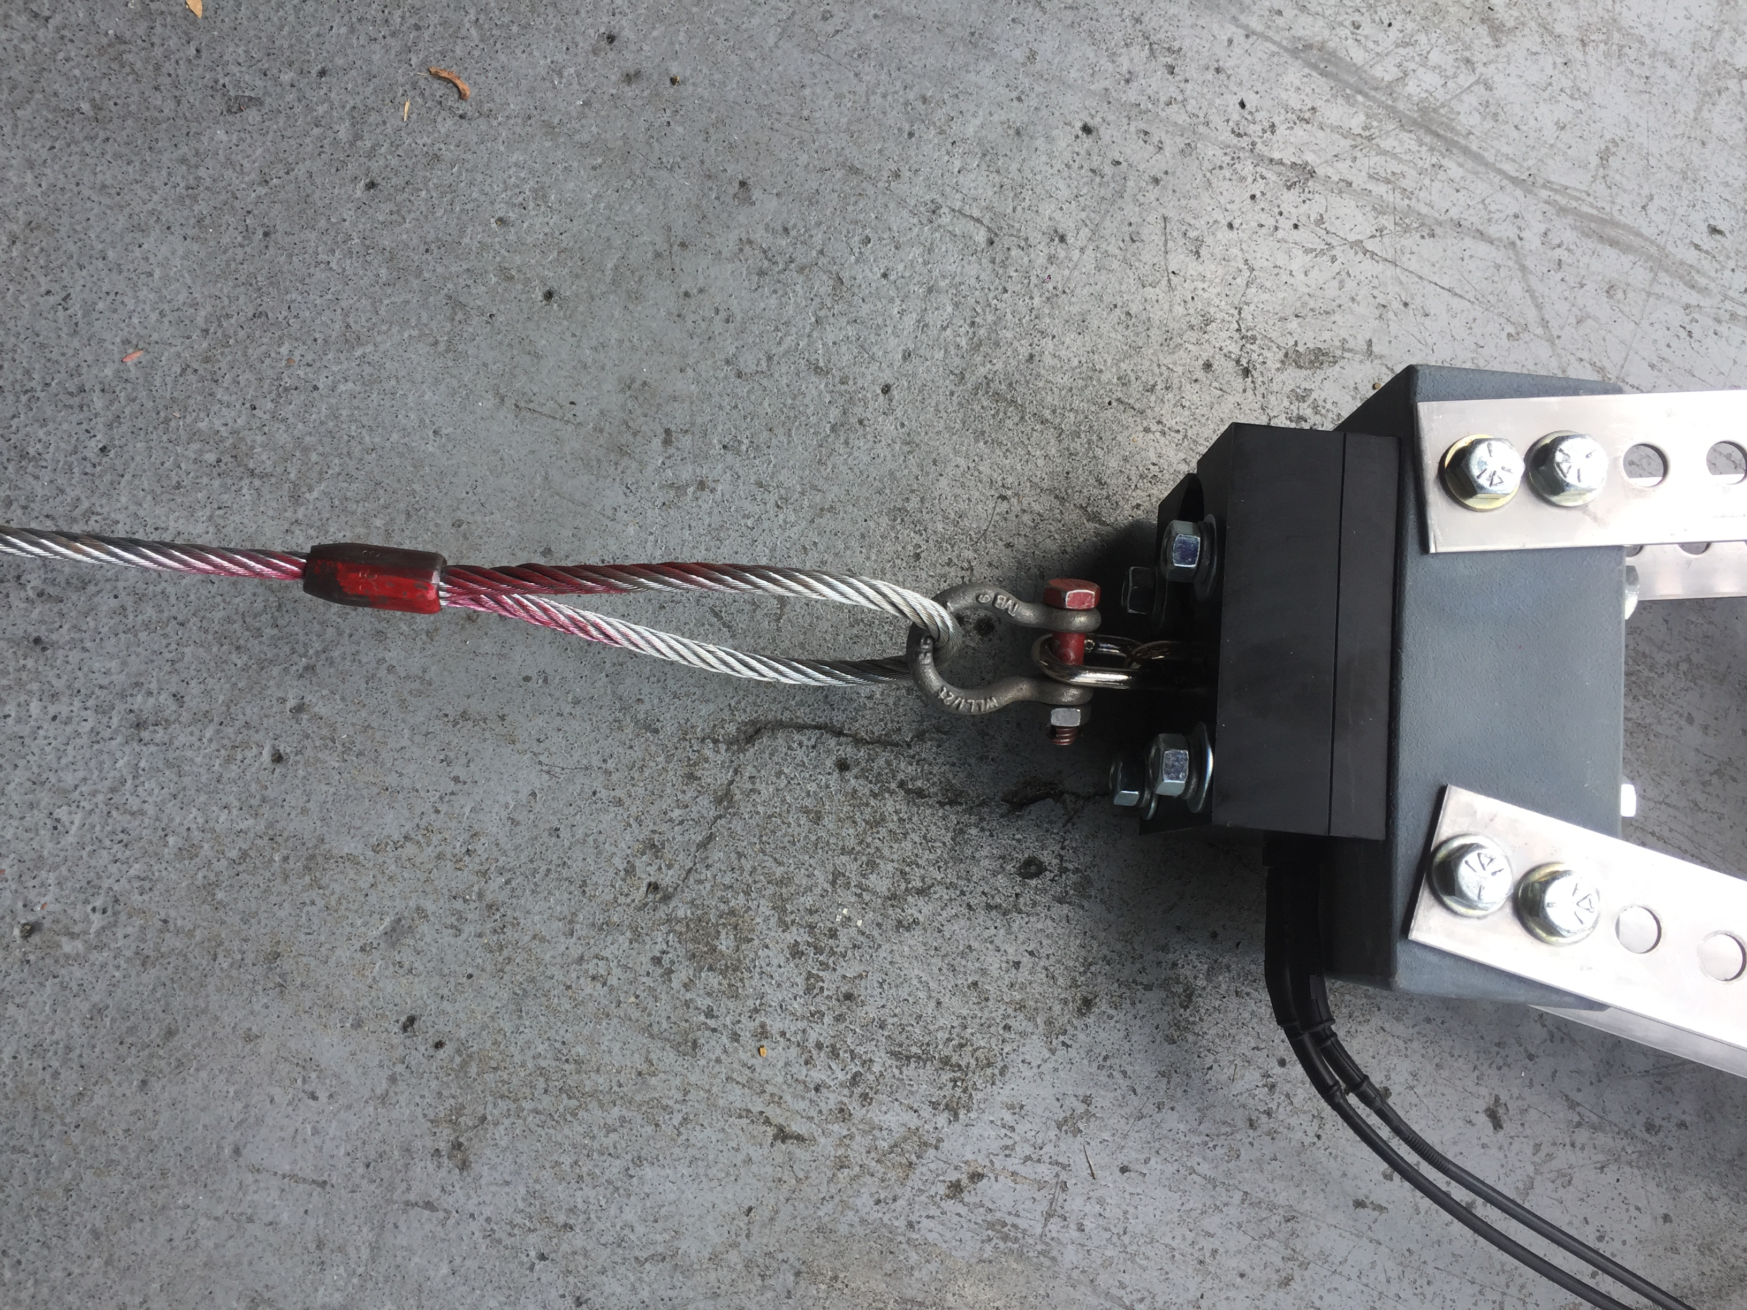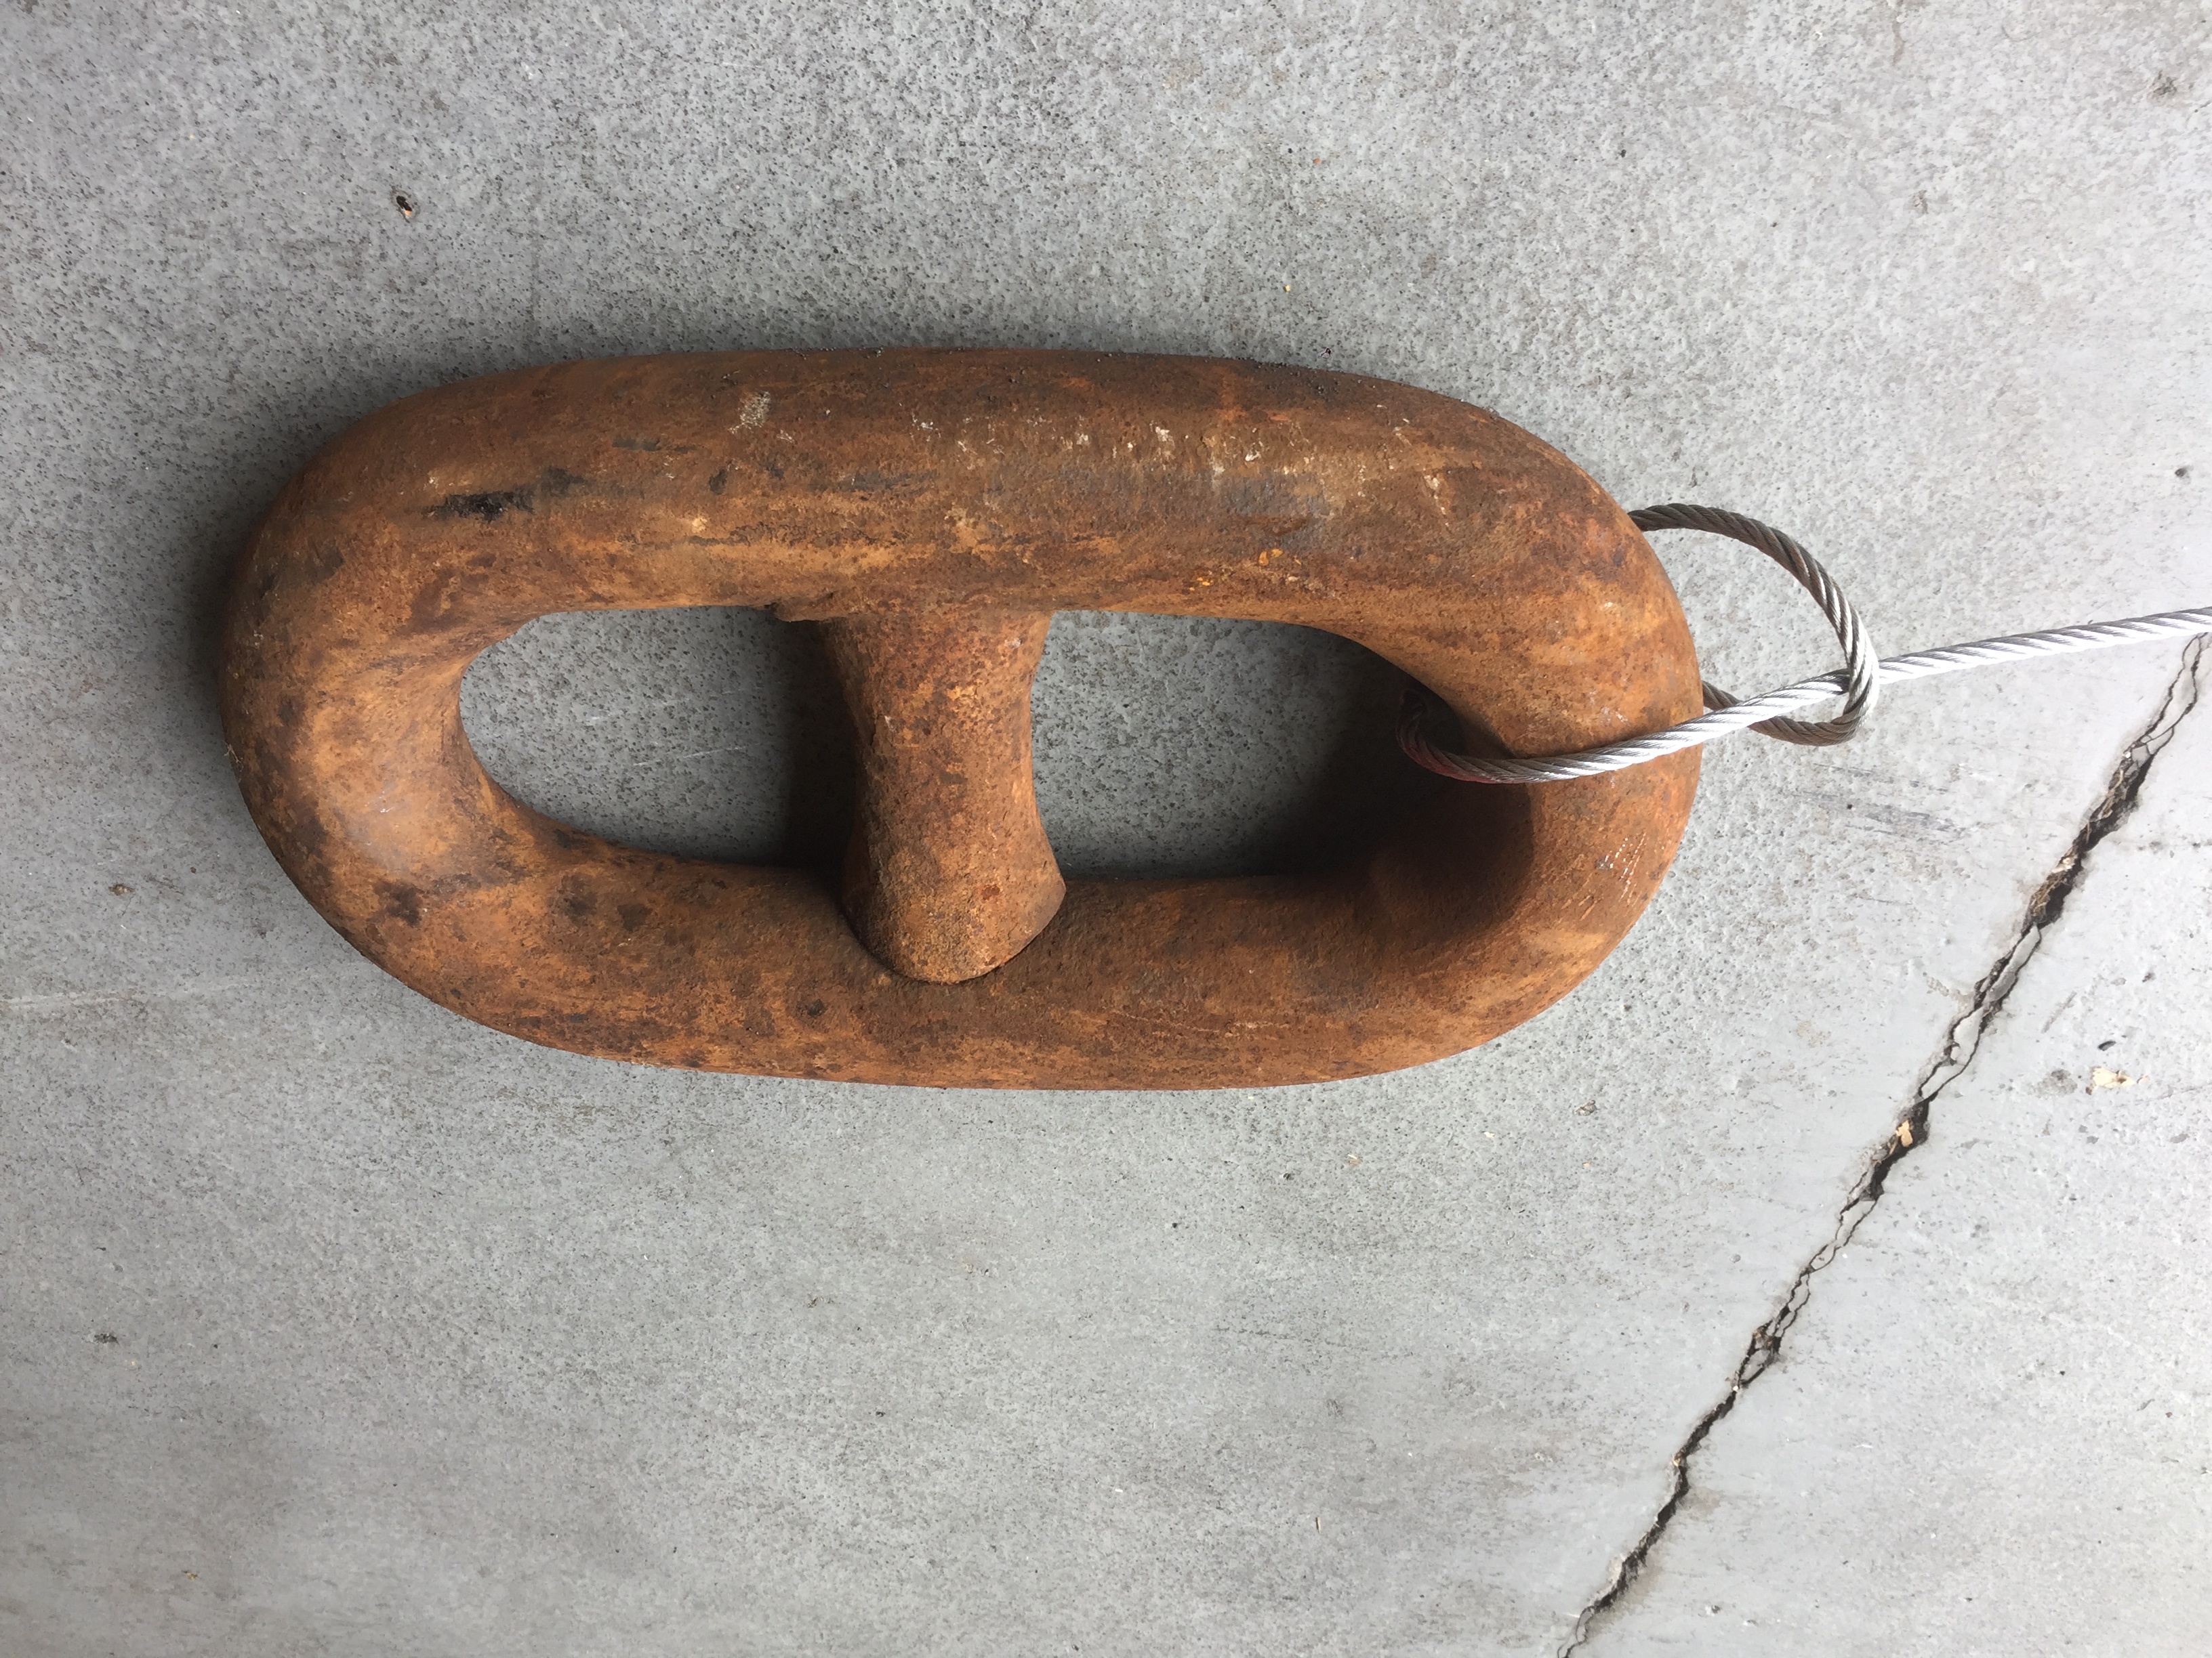

**1) Attach Anchor**

1. **Loop the anchor cable** around the anchor chain link and back through the cable eye in a hitch
2. **Attach the free end of the cable to the lower chain link on the release block** via the shackle. Use a cotter pin to secure shackle.